National University of Computer and Emerging Sciences



Lab Manual 02

Database Systems Lab

|  |  |
| --- | --- |
| Course Instructor | Ms. Aleeena |
| Lab Instructor (s) | M Usama Alam  Tahreem Saeed |
| Section | BCS-4E |
| Date | February 7, 2023 |
| Semester | Spring 2023 |

Department of Computer Science

FAST-NU, Lahore, Pakistan

## Objectives

After performing this lab, students shall be able to:

* Tables Definition through Design view
* Getting to know SQL Server 2008 Import Export
* Data population through Query and Design view
* Data Import from Files.i-e Flat file, excel.

# Lab Manual

## Creating Database:

* Right-click the **Databases** node in the Object Explorer and select the **New Database**… menu item
* Enter the Database name and click the OK button to create the new database.

## Create Table Via Design View:

* Expand **Databases** and **DemoDB**, right-click the Tables folder, select New > Table

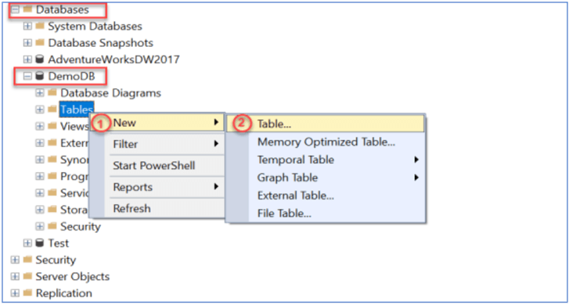

* To create a basic SQL table, we need to provide a Column Name, Data Type and if the column will Allow Nulls.

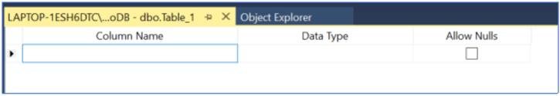

## Data population through Design view

* Expand **Databases** and Right click on the **desired** table
* Select **Edit Top 200 Rows** and enter data as required. Then click the X to close and save the records.

## Data population through Query

* Create a database.
* From the File menu, choose Open > File… menu item to open a script file.

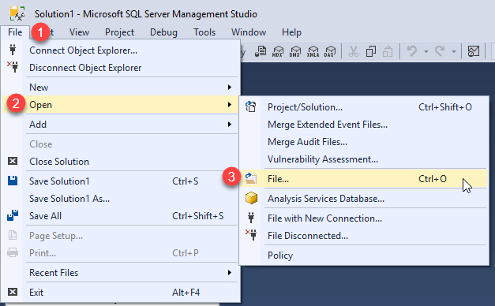

* Select the sql file and click the Open button.
* Click the **Execute** button to execute the SQL script.
* Go to Design View and see what tables are created and what data is populated.

## Importing Data from File

* Expand **Databases**.
* Right-click a database.
* Point to **Tasks**.
* Click on **Import Data**

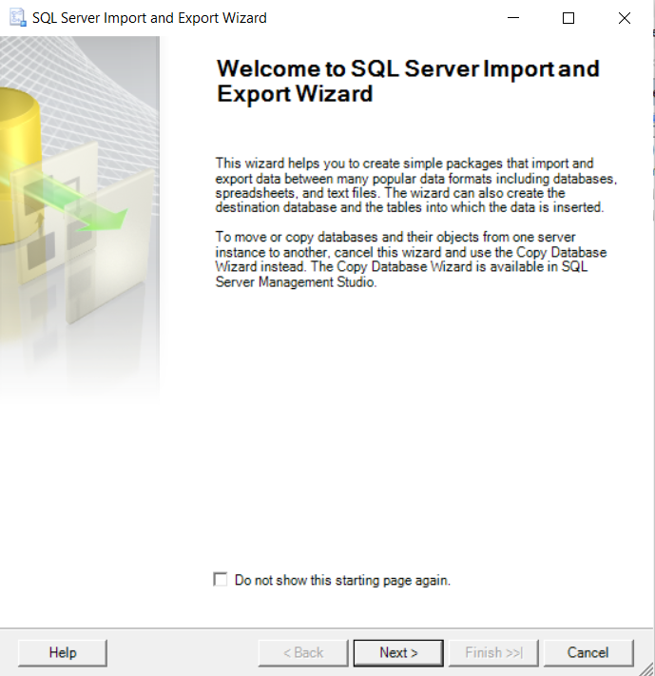

* On the next page, **Choose a Data Source.** i.e. Flat File or Excel. Carefully select the format of source file i.e. delimited or not, if there are column names in first row etc.
* Next, Review the data of file in wizard.
* On the next page, **Choose a Destination** and **Server Name**, you can pick Microsoft SQL Server as your destination.
* Review the mapping of source file and destination table.

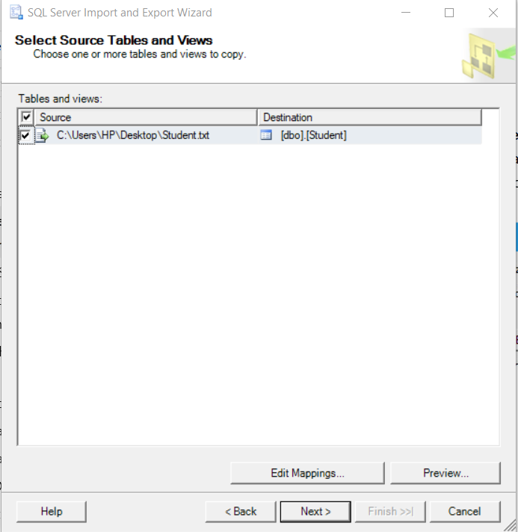

Click the **Edit Mappings** button to open the **Column Mappings** dialog box. Here, in the **Mappings** table, you see how the wizard is going to map columns in the source worksheet to columns in the new destination table. You can preview the table as well.

* Select Copy Data from one or more tables or views.

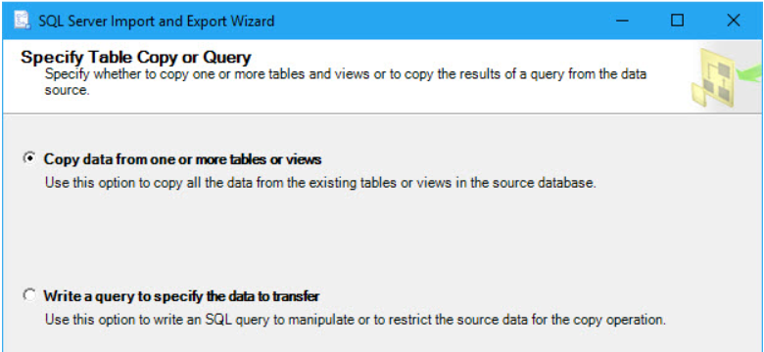

* **Select Source Tables and Views**, pick the table or tables that you want to copy from the data source.
* Run and finish the wizard.

# Lab Exercise

1. Create a new database in named 20L-5894_Lab01.
2. Create the following Tables using Design View.

**Student:**

|  |  |  |  |
| --- | --- | --- | --- |
| **RollNum** | **Name** | **Gender** | **Phone** |
| L164123 | Ali Ahmad | Male | 0333-3333333 |
| L164124 | Rafia Ahmed | Female | 0333-3456789 |
| L164125 | Basit Junaid | Male | 0345-3243567 |

**Attendance:**

|  |  |  |  |
| --- | --- | --- | --- |
| **RollNum** | **Date** | **Status** | **ClassVenue** |
| L164123 | 2-22-2016 | P | 2 |
| L164124 | 2-23-2016 | A | 1 |
| L164125 | 3-4-2016 | P | 2 |

**ClassVenue:**

|  |  |  |  |
| --- | --- | --- | --- |
| **ID** | **Building** | **RoomNum** | **TeacherId** |
| 1 | CS | 2 | 1 |
| 2 | Civil | 7 | 2 |

**Teacher:**

|  |  |  |  |
| --- | --- | --- | --- |
| **ID** | **Name** | **Designation** | **Department** |
| 1 | Ali Ahmed | Assistant Prof. | Computer Science |
| 2 | SamanAyyaz | Lecturer | Civil Eng. |
| 3 | Bilal Haider | Professor | Electrical Eng. |

1. Populate Student and Attendance via Design View (RollNum should not be nullable).
2. Populate Table **ClassVenue** and **Teacher** via Importing ClassVenue.txt and Teacher.csv (ID of either table should not be nullable).
3. Create another database using scripts provided in BikeStores-create objects.sql and BikeStores–load data.sql